Assignment3 Report

Anqi Miao, Shaolong Feng and Ziming Gong

In assignment3, we design an application for searching the best course and the best college in Boston. The result of colleges will be determined by the value that submitted by admins; the result of courses will be determined by some data which is submitted by the student who had graduated from their college.

The number of courses which selected in this application is six – “Application Engineering and Development”, “Business Analysis and Information Engineering”,” Planning and Managing Information Systems Development”, “Web Design and User Experience Engineering”, ”Advance Application Engineering Project” and “Engineering of Big-Data Systems”.

The number of college in Boston is five—“Northeastern University”, “Harvard University”, “[Massachusetts](javascript:;) [Institute](javascript:;) [of](javascript:;) [Technology](javascript:;)”, “Boston University” and “[Berklee](javascript:;) [College](javascript:;) [of](javascript:;) [Music](javascript:;)”

Overall, the rank of university will be determined by professor number, project number and funding which will be inputted by admin. And the rank of courses will be determined by the graduate student performance (such as their salary range, the promotion when they are employed and the company). The formula will be posted below.

**object model diagram**

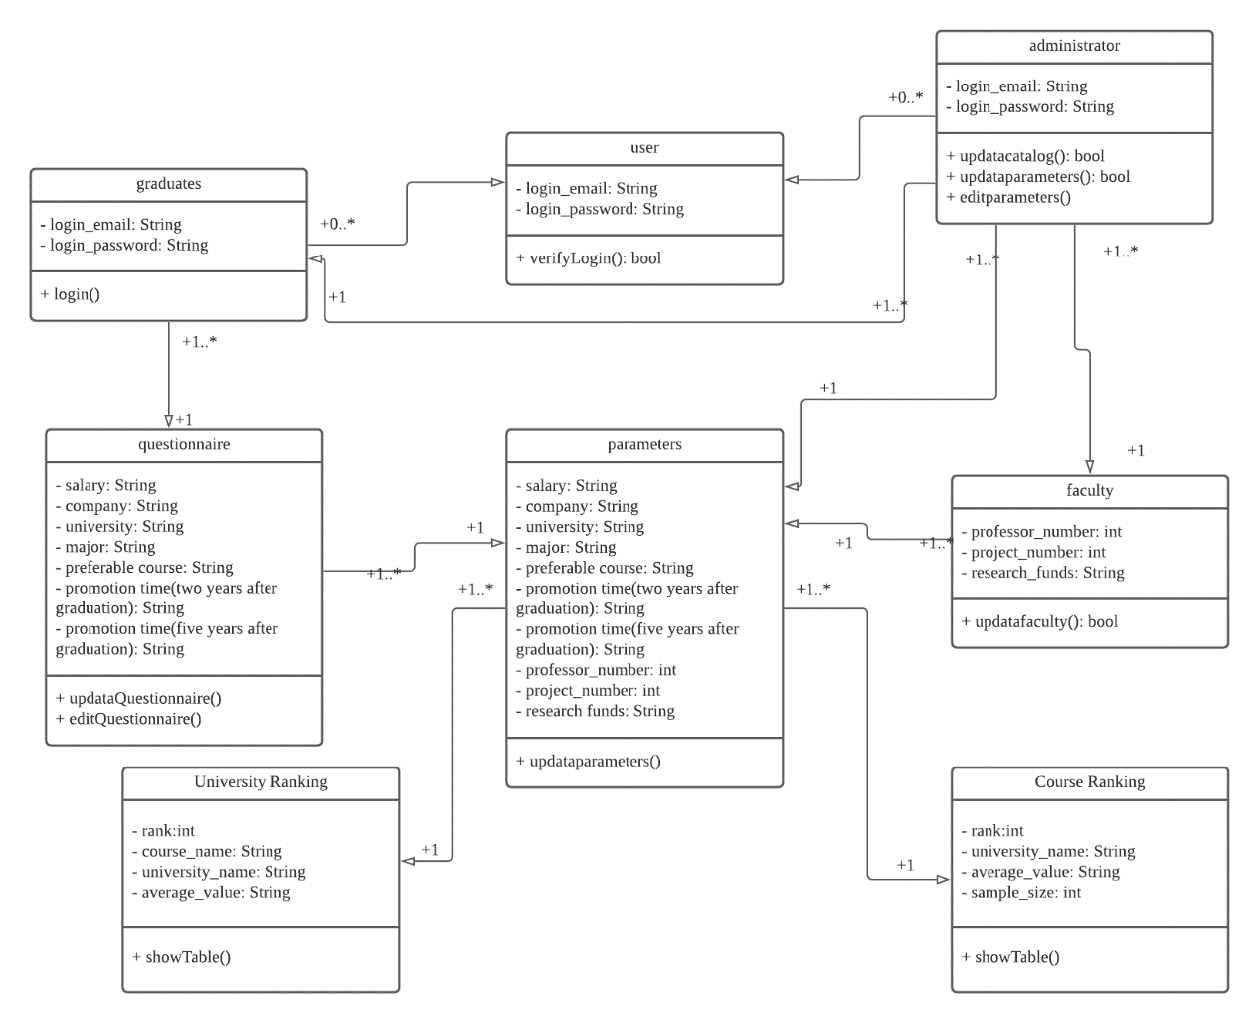email: string

password: string

salary: String

company: String

university: String

major: String

preferable course: String

promotion time(two years after graduation): String

promotion time(five years after graduation): String

professor_number: int

project_number: int

research_funds: String

rank:int

course_name: String

university_name: String

average_value: String

sample_size: int

Create on: Date

Courses score:

50%salary+20%*promotion time(2 years after graduation)+20%*promotion time(5 years after graduation)+10%company level.

University score:

40%sum of courses score / courses number+20%professor number +20%project number+20%research funds.

**Sequence diagram**

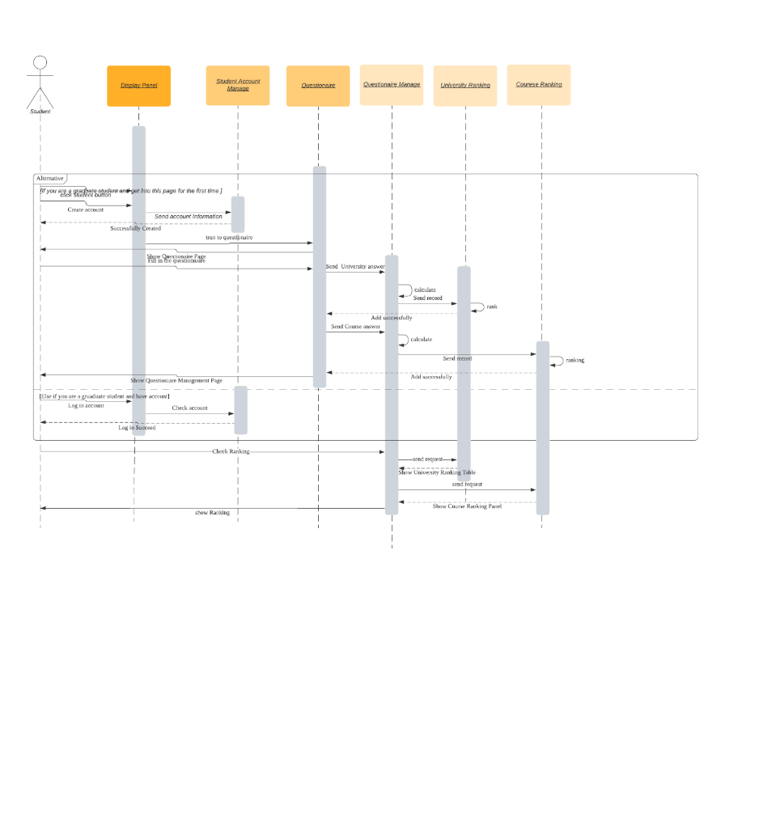

This is our student user sequence diagram. For graduate users, if they are the first users to enter the interface, they need to sign up for an account. Then they need to fill out a questionnaire. The questionnaire information will be sent to the questionnaire management interface. The data will be calculated and ranked. For students who already have an account, they need to log in. After that, they can manage to update their own questionnaire information. Student users can view school and course rankings.

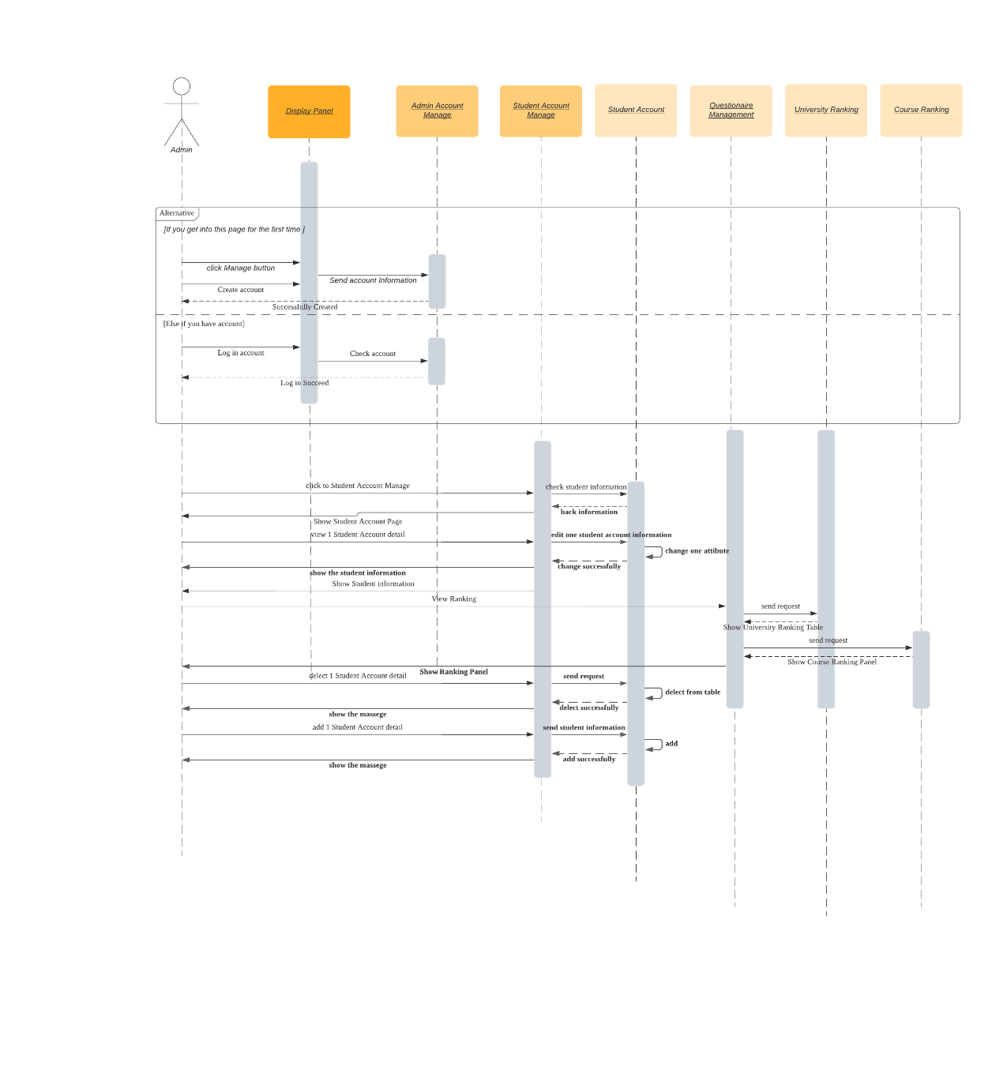

This is our administrator sequence diagram. For these users, they can manage students' accounts. They can add, delete and modify student accounts. At the same time, they can also view the rankings. Again, they need to register or log in first to perform these operations.

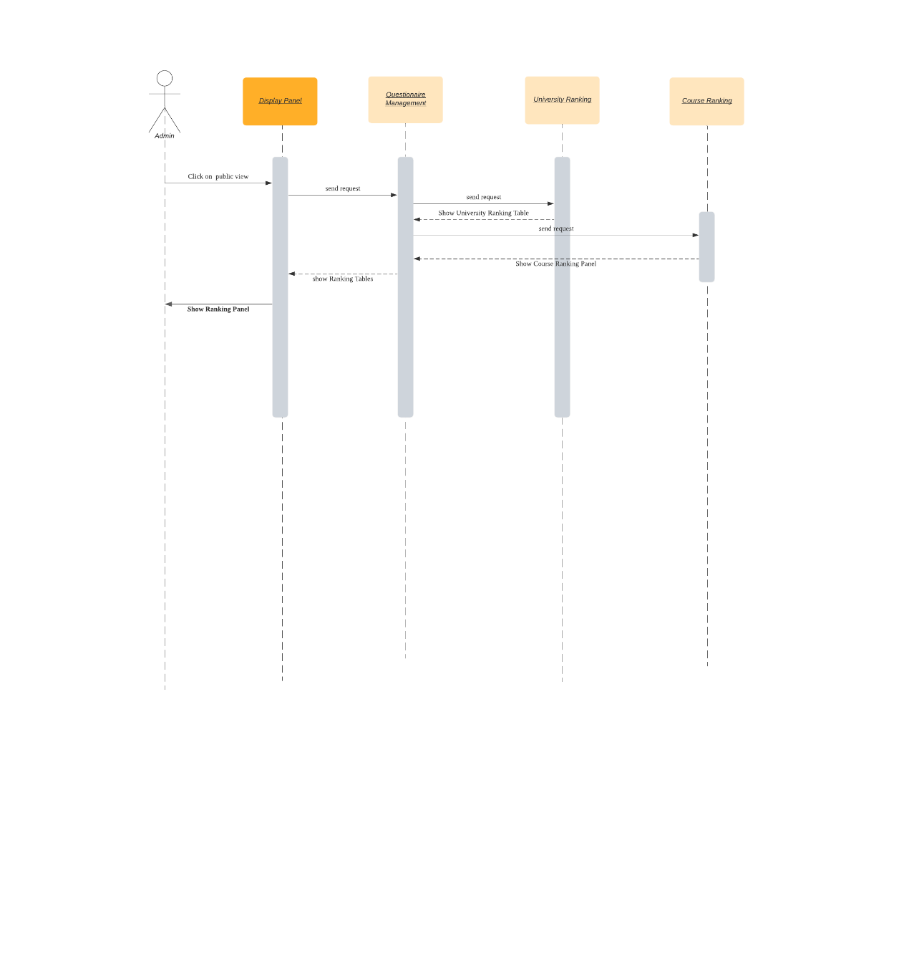

The last one is the viewer's sequence diagram. They can view the rankings directly without having to log in.

**GUI**

Main Frame: This is the main JFrame. There are three button on right panel—admin, graduate student and public view. Because this application is work for search the best college and courses for teenagers who are going to college, they could see the result directly without any login.

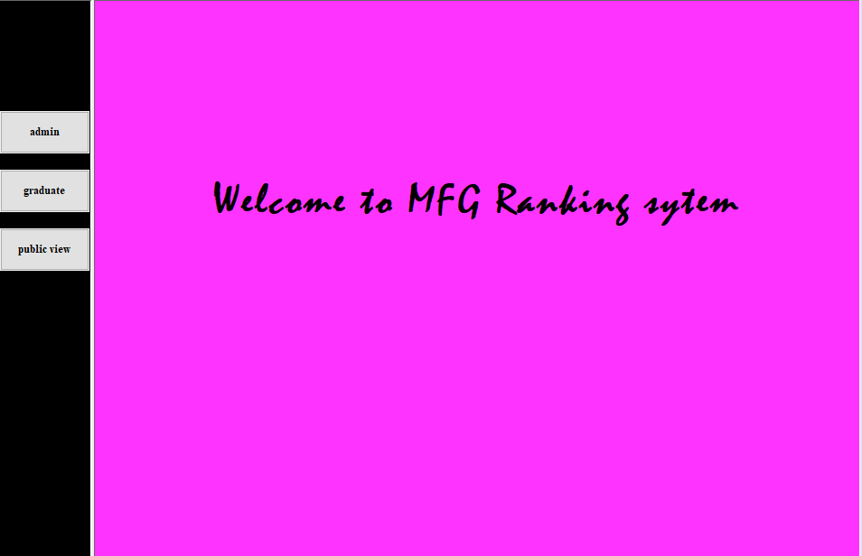

Login panel: The login panel is work for admins and graduate students. The new could use the create button to create their account first.

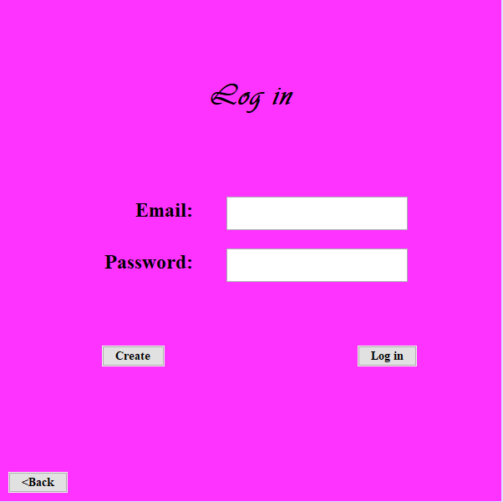

Create account panel: Your email will be as your account to login. People need to make sure that their password is correct

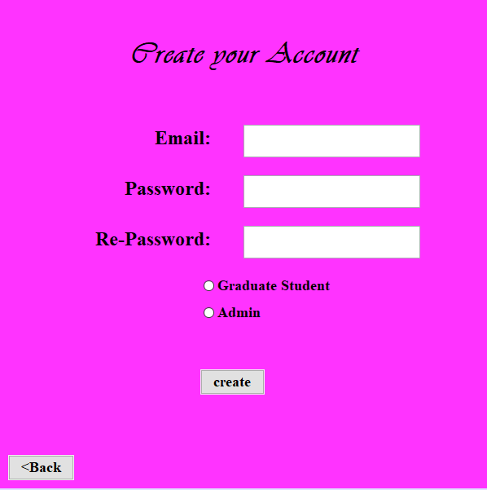

Admin work sheet Panel: There are four main functions for admin--managing graduate student, managing all record, inputting the college for ranking and managing the college information.

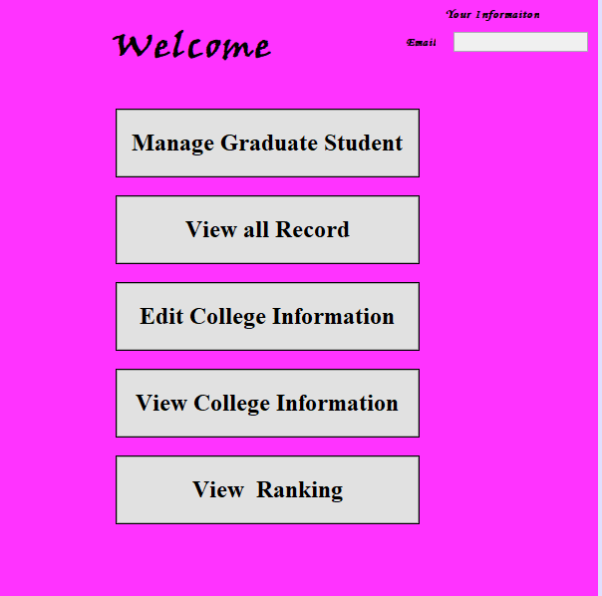

Manage graduate school account: Admins are allowed to edit the graduate students’ account. For example, someone might forget their password, and they could change it with admins. And the admin will delete some fake accounts

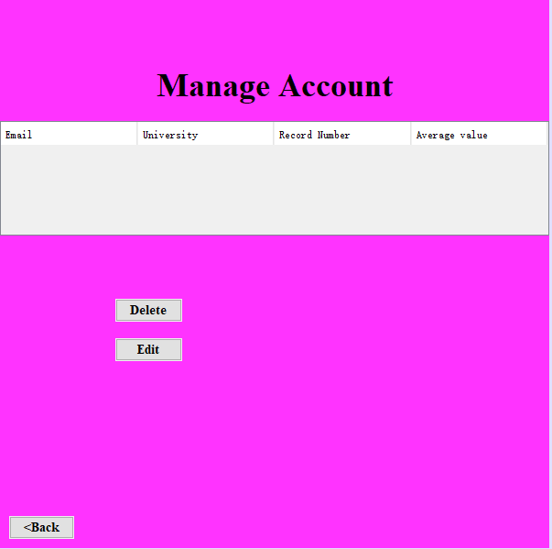

Edit Account: Account password and email could be changed in this page.

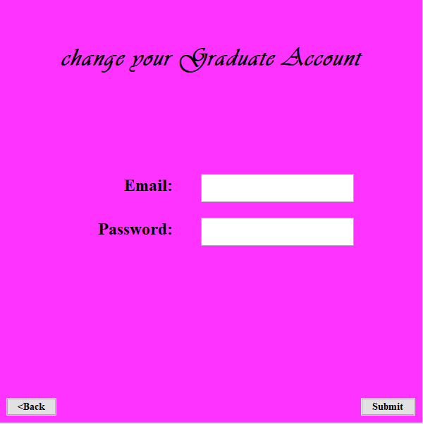

View all record: In this panel, admins could review all record here, but they could change any details. The only thing for admins is to verify the authenticity of them.

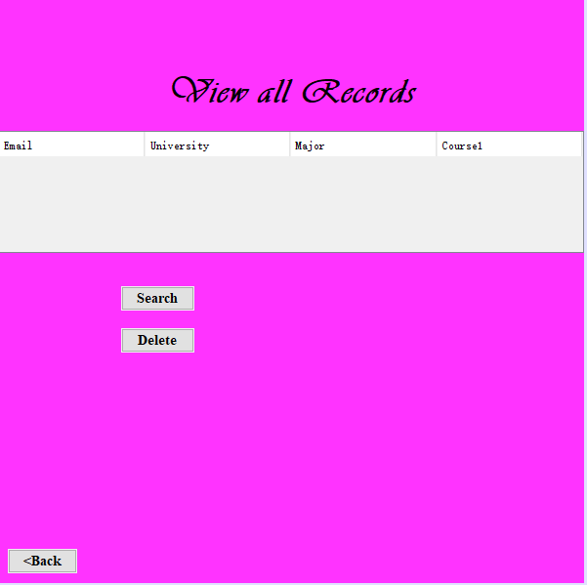

Record details: Admins could select any record for checking its detail.

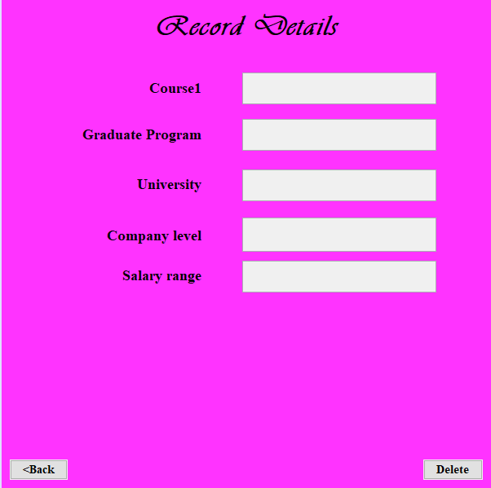

Add college information: admins should add some information for college ranking, these four things will determine the school ranking.



View all colleges information: They could review the school information here

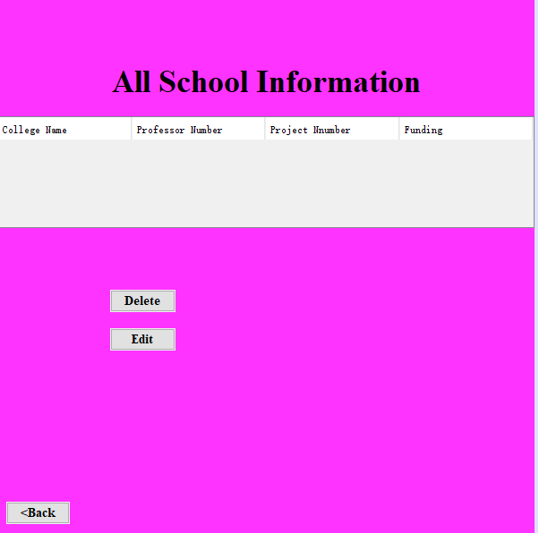

Change college information Panel: admins are allow to edited their information if something is refreshed.

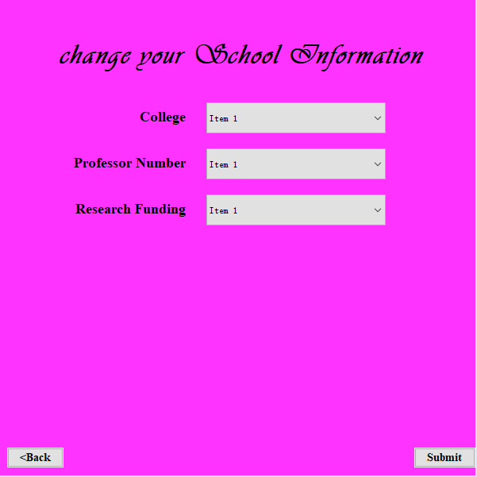

Graduate Work sheet Panel: this is work sheet for graduate student. They can check their former record and add a record here.

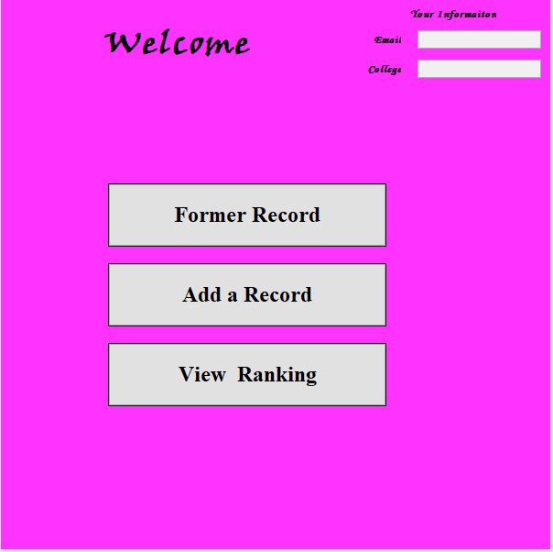

Recording History Panel: this panel is for graduate students to viewing what they wrote before and if there are some mistakes, they could edit it.

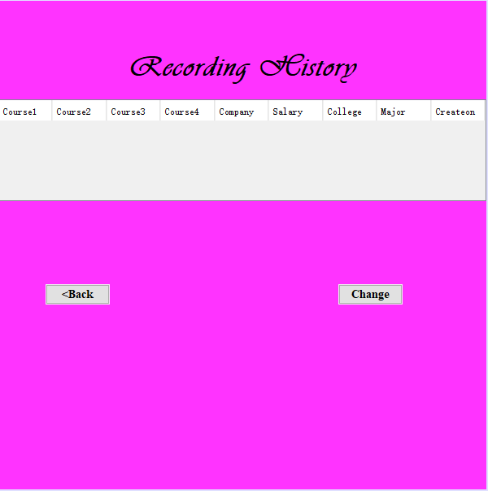

Change your Record Panel: graduate students are allowed to change their records, if there are something wrong.

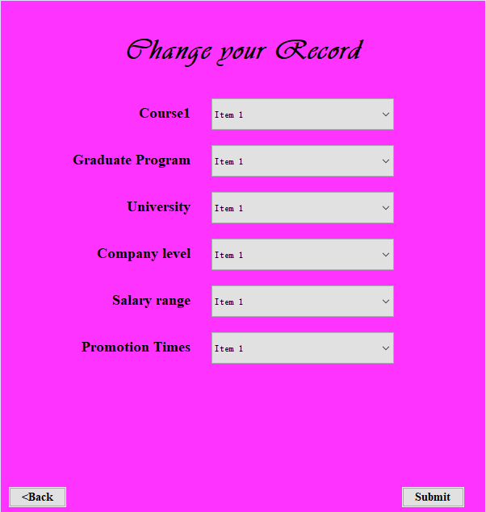

Add your record Panel: in this panel, graduate students could add their information which will determine the ranking of course and college ranking.

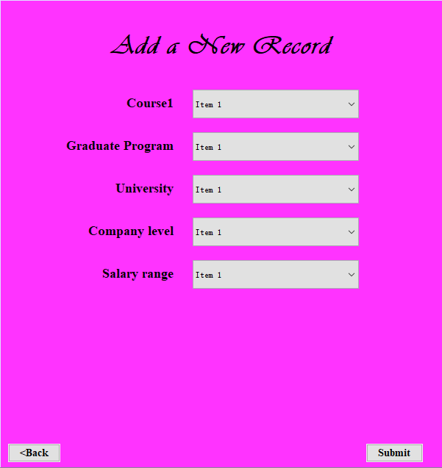

Public review panel: this panel is for general people, but if you login, you can also entry it in the specific worksheet. General people are allow to view the result without creating anything before. it is work for public.

